**WITKOP HUNTING SAFARIS**

**PRICELIST 2024**

**Porcupine $150.00 Vervet Monkey $150.00**

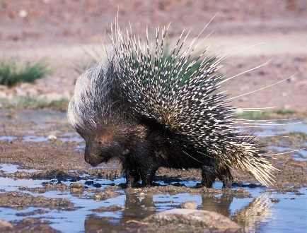 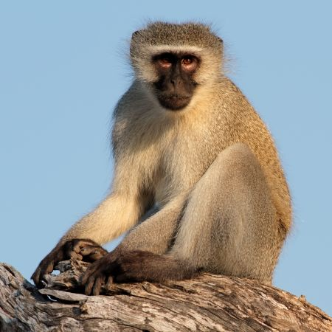

**Baboon $250.00 Jackal (Black-backed) $150.00**

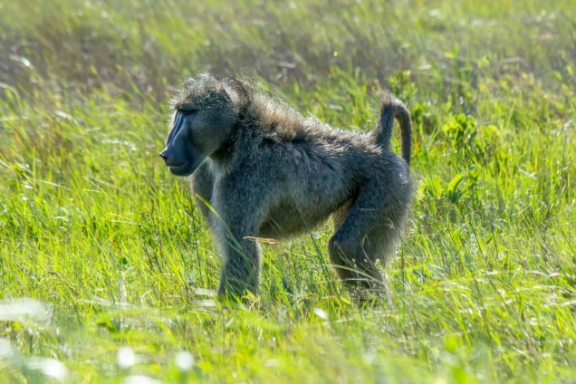 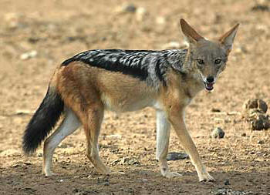

**Caracal $1000.00 Serval $1000.00**

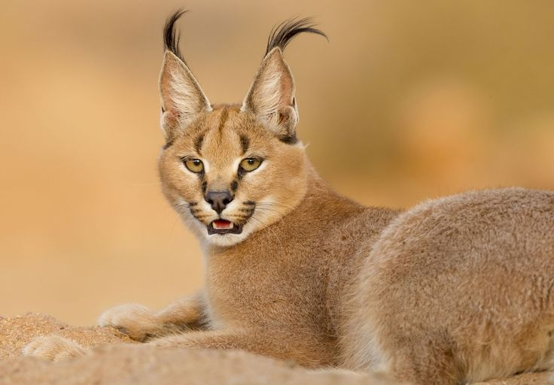 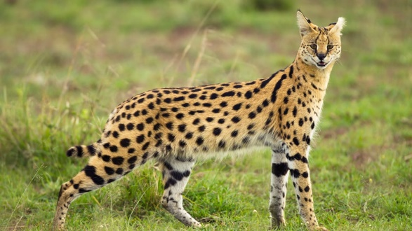

**Brown hyena $3500.00 Steenbuck $500.00**

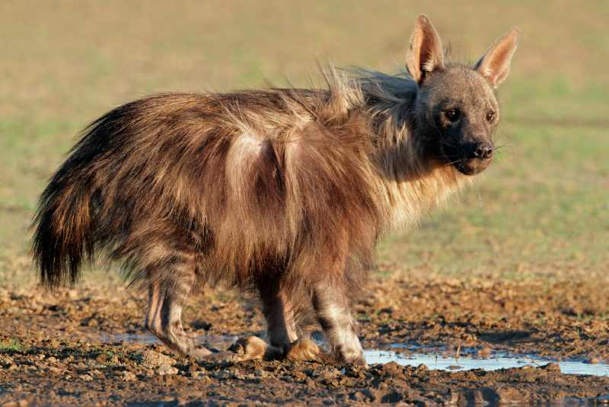 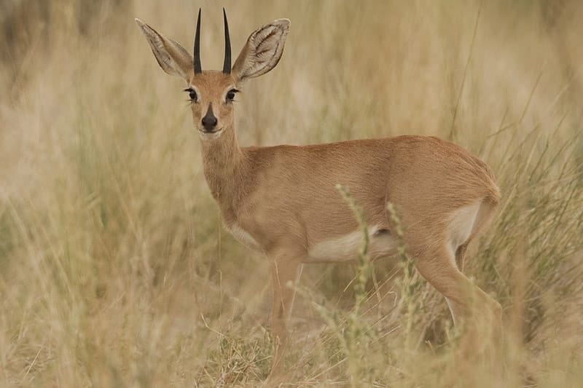

**Grey Duiker $500.00 Klipspringer $2000.00**

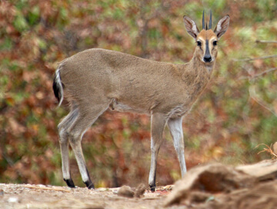 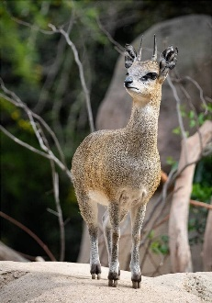

**Warthog $500.00 Bushpig $1000.00**

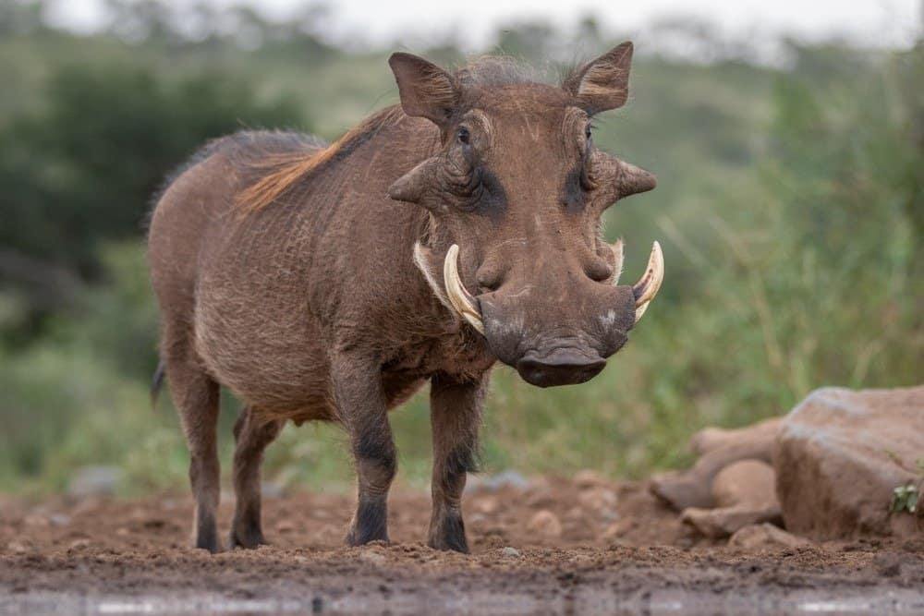 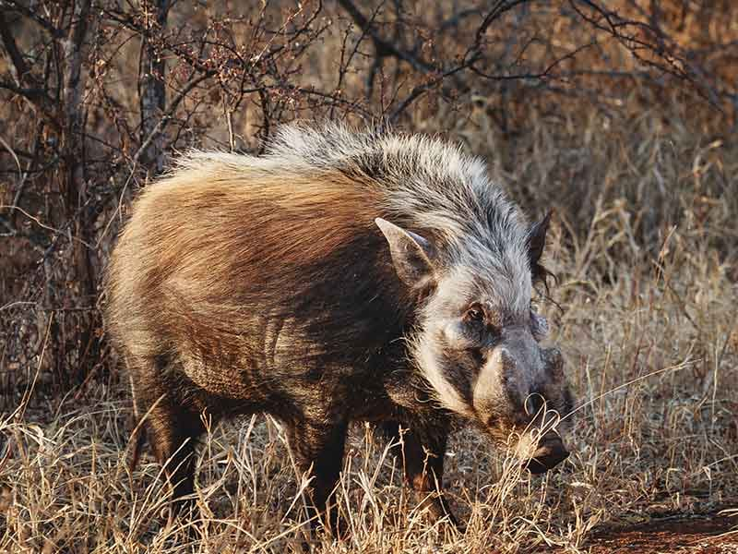

**Ostrich $600.00 Impala $550.00**

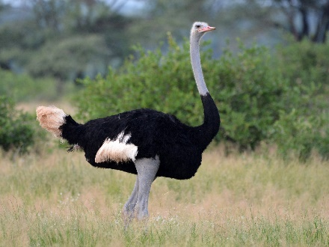 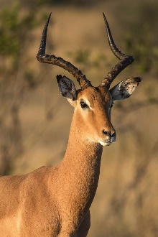

**Impala (Black-faced) $800.00 Impala (Black) $ 2350.00**

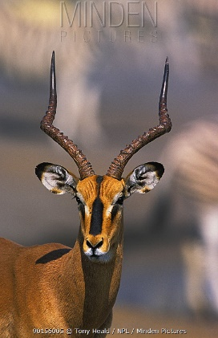 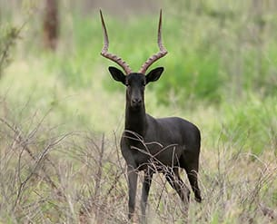

**Impala (White-flank) $ 4000.00 Blesbuck $ 550.00**

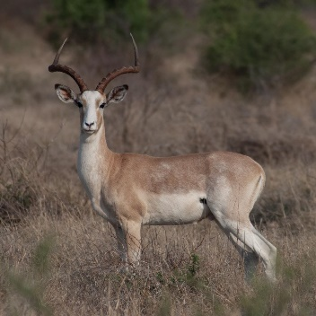 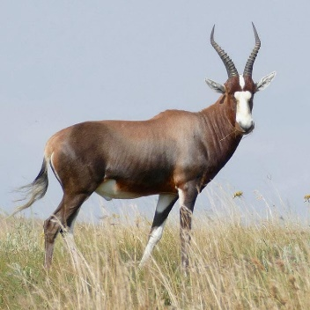

**Blesbuck (White) $ 650.00 Springbuck (Common) $400.00**

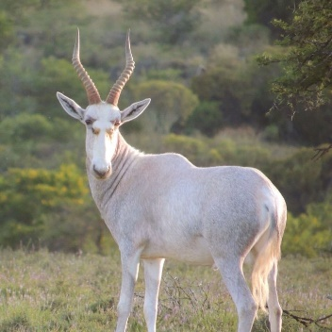 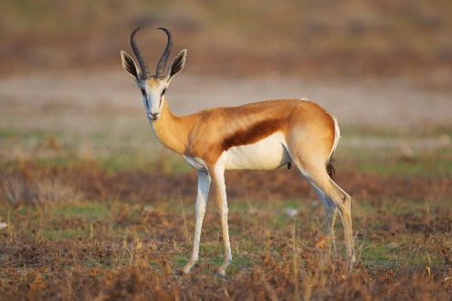

**Springbuck (Kalahari) $400.00 Springbuck (White) $1350.00**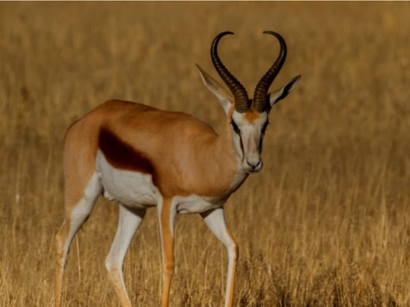 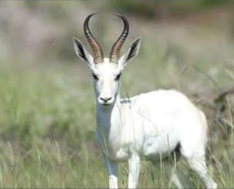

**Springbuck (Black) $1350.00 Springbuck (Copper) $1350.00**

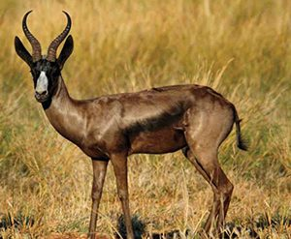 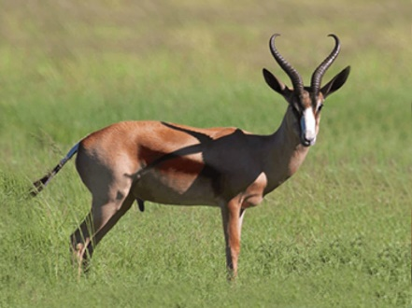

**Mountain Reedbuck $1400.00 Vaal Reedbuck $1600.000** 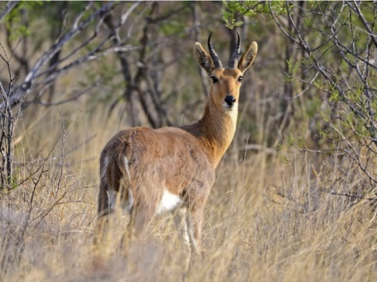 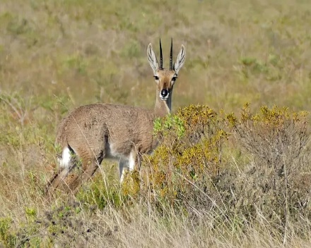

**Common Reedbuck $2000.00 Fellow Deer $1200.00**

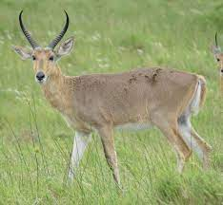 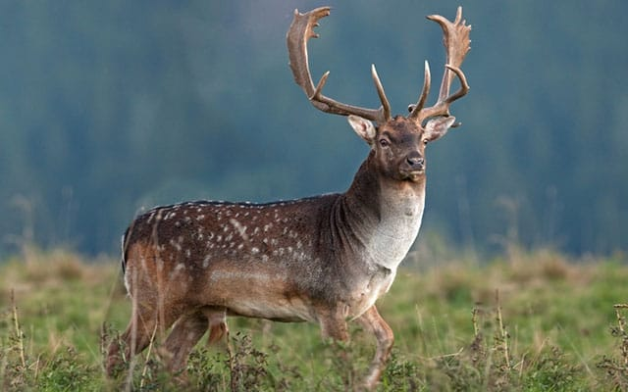

**Bushbuck $1800.00 Nyala $2400.00**

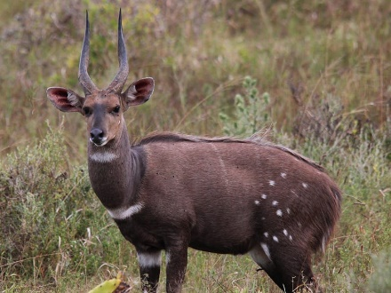 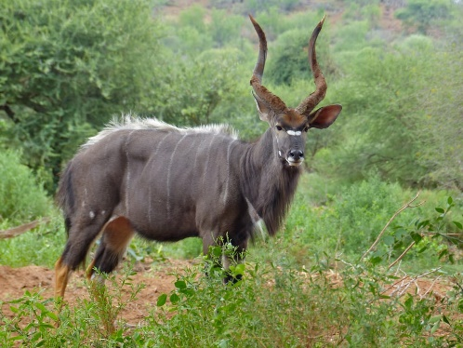

**Lechwe $3800.00 Tsessebe $3500.00**

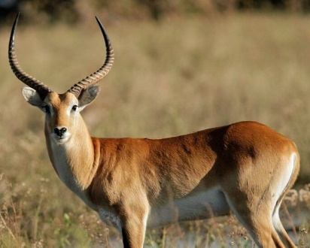 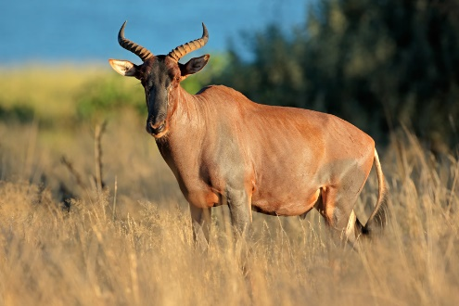

**Zebra (Plains) $1200.00 Waterbuck $2500.00**

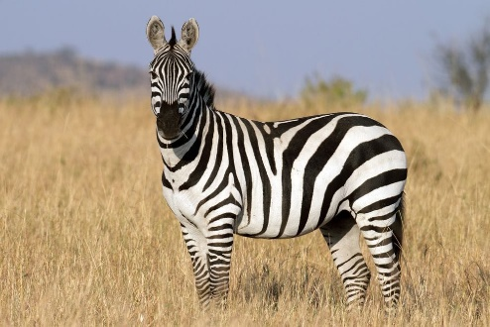 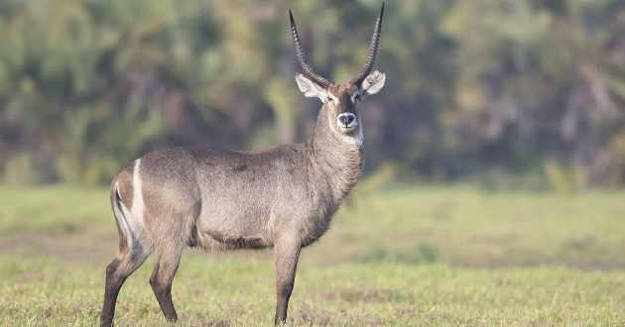

**Black wildebeest $990.00 Red hartebeest $1200.00**

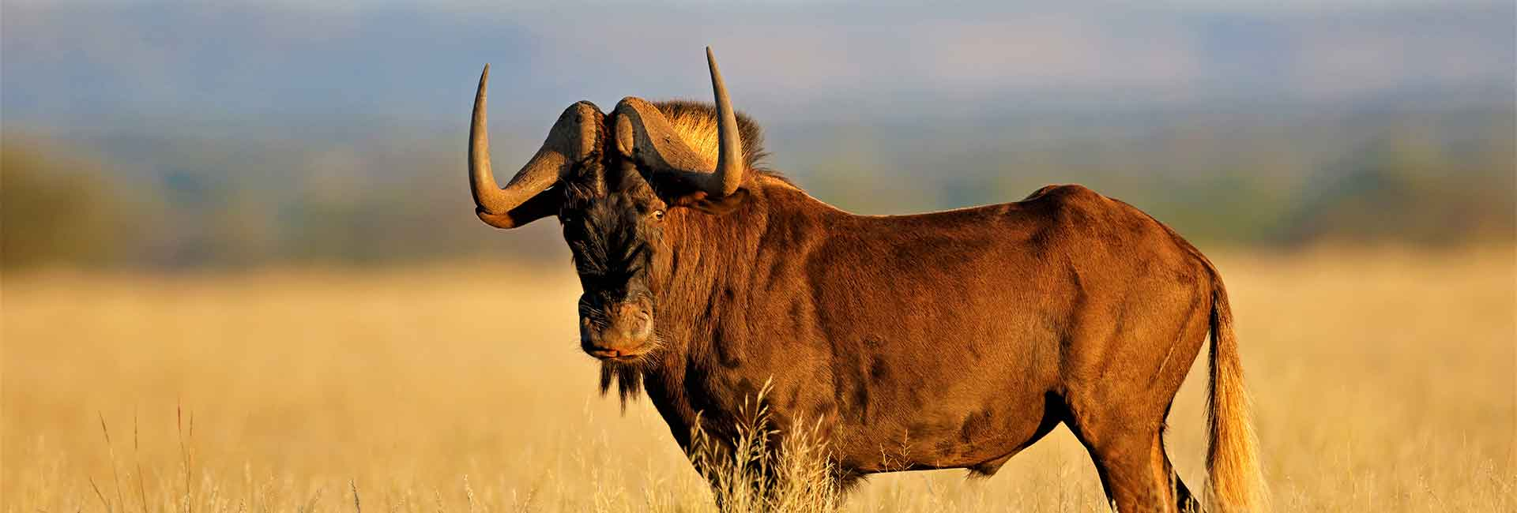 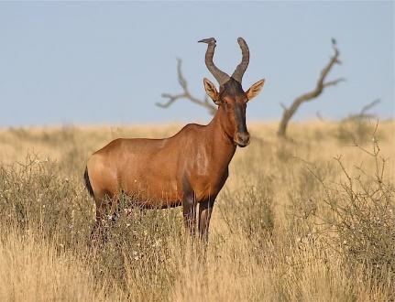

**Blue wildebeest $990.00 Golden wildebeest $3800.00**

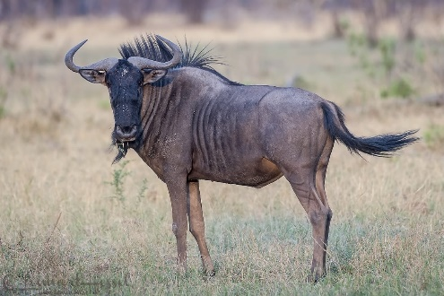 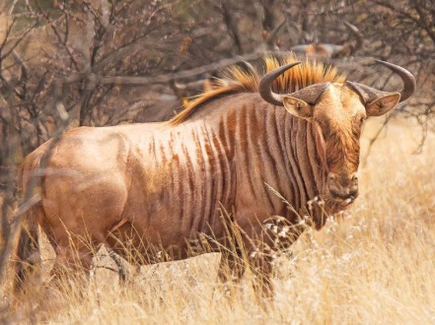

**Sable $3700 Roan $5200.00**

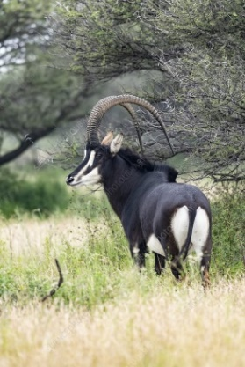 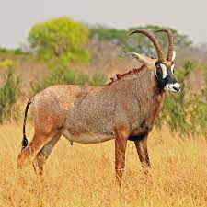

**Kudu $3500.00 Oryx $1700.00**

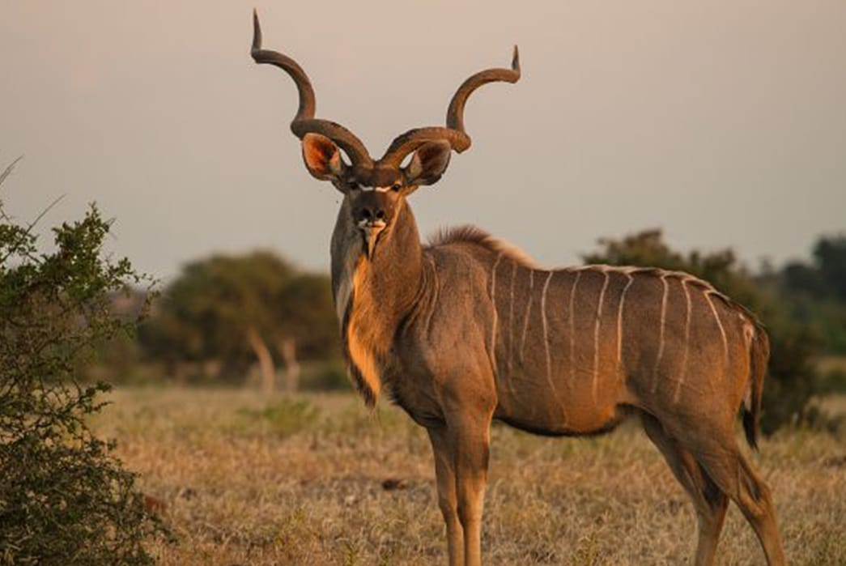 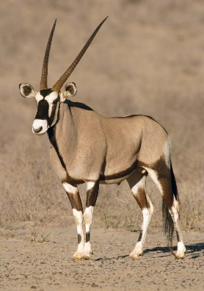

**Eland (Cape) $3200.00 Eland (Livingstone) $4000.00**

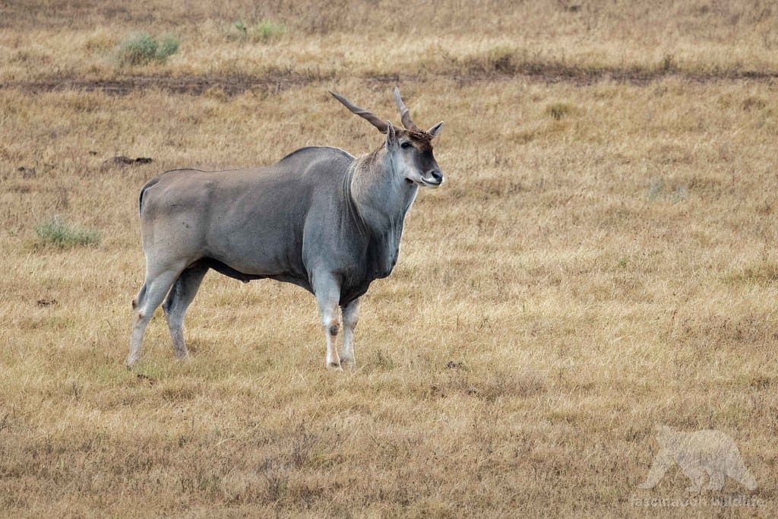 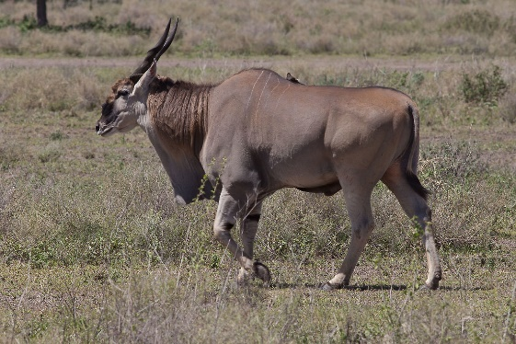

**Crocodile (Nile) $ Price on request Giraffe $3800.00**

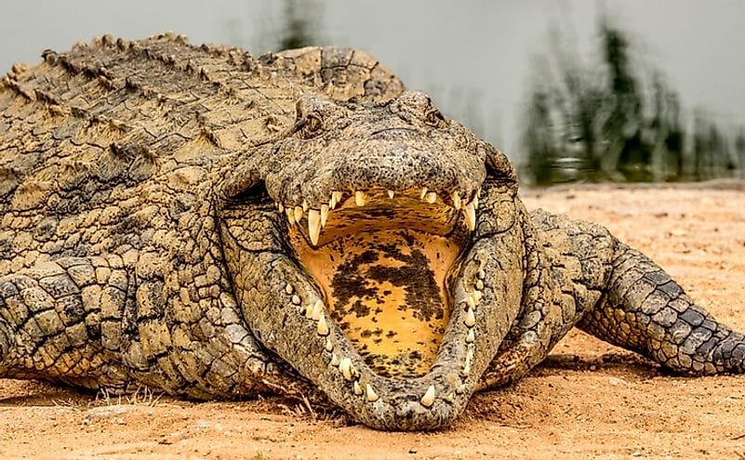 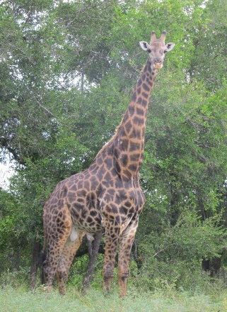

**Dangerous Game**

**Cape Buffalo $ 13 000.00**

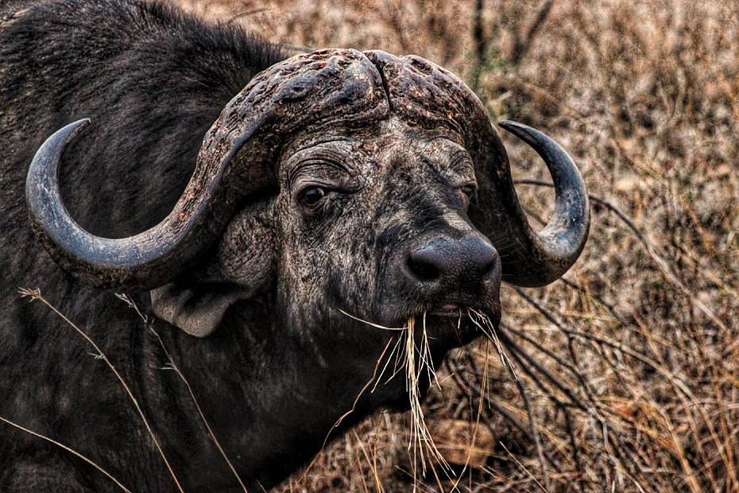

**Hippo $ Price on request**

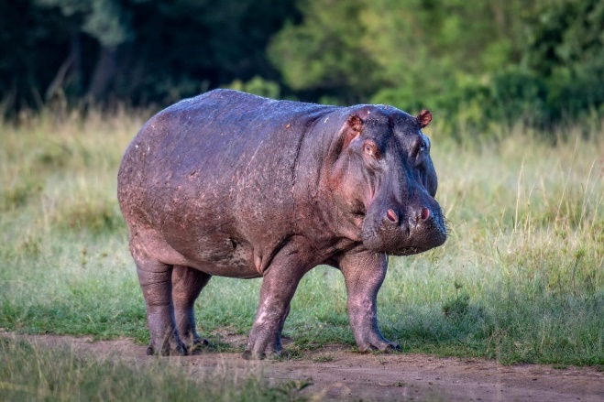

**White Rhino $ Price on request**

